**Table of Content**

|  |  |
| --- | --- |
| Cover Page | 1 |
| Table of Content | 2 |
| 1.0 Introduction | 3 |
| 1.1 Objectives | 3 |
| 1.2 Project Scope | 3 |
| 1.3 Tools and Technology | 3 |
| 2.0 System Analysis | 4-12 |
| 2.1 Case Diagram | 4 |
| 2.2 UML Class Diagram | 5 |
| 2.3 Class Diagram | 6 |
| 2.3 System and Design Explanation | 7 |
| 3.0 System Maintenance | 8-9 |
| 3.1 Strength | 8 |
| 83.2 Weakness | 8 |
| 3.3 Future Enhancement | 9 |
| 4.0 Appendix | 10-160 |
| 4.1 Acceptance Testing | 10-17 |
| 4.2 Source Code | 18-126 |
| 4.3 Screenshots and Explanation | 127-158 |
| 4.4 Completed Self-Assessment | 159-160 |

**1.0 Introduction**

The Game Application System is a complete desktop based application designed on .Net using Visual Studio Software. An educational company who provides educational support to children between 5 to 16 years decided to distribute to the pupils educational games or quizzes. The main goal is to develop educational based game application system for pupils between 5 to 16 years old.

**1.1 Project Objective**

The purpose of the project is to develop and build educational game to children between 5 to 16 years old. This project includes a complete level of game with documentation. This game will be a single-player educational game. The purpose of the project is to design and implement a 2 dimensional game written in C# language and using SQL Server.

**1.2 Project Scope**

The system will be develop using C# as well as store all the data in Microsoft SQL.

Memory Game allow to do all the following:

1. Start game
2. Choose the Category
3. Selecting game level
4. Able to view his or hers past score as a Graph.
5. Able to view the score for each category and level Selection.
6. View the ranking list
7. Exit

**1.3 Tools and Technology**

I will be using Acer Aspire E15 which is i5 processor and NVDIA GEFORCE graphic card to do this project. The operating system used is Windows 10 Home single language with the latest update. The software used for this project is Microsoft Visual Basic 2017 to do the coding for the Memory Card Game and Microsoft SQL Server to store all the database.

**2.0 System Analysis**

**2.1 Use Case Diagram**

<Include>

Player

Score board

Main Menu

**2.3 UML Class Diagram**

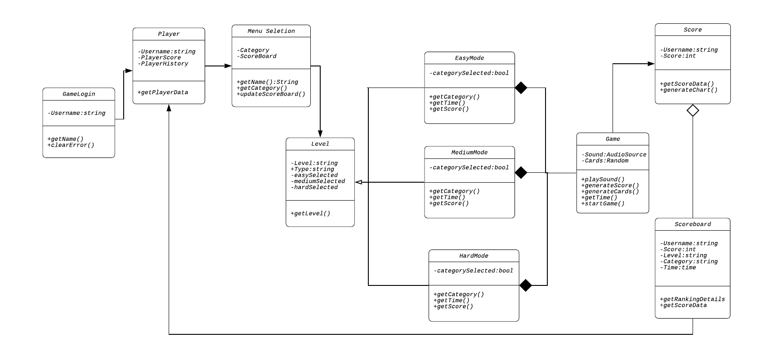

**2.3 System and Design Explanation**

As a contractor developer, I was approached by new educational service company called FED Company. The FED Company wanted to provide educational Memory card game to pupils within the age of 5 to 16 years old. The game application system is designed in a way of flexible and user-friendly for them. Memory Game Application is a simple desktop based game application which is suitable for children with age group of 5 years to 16 years old. This game can be used for infinite number of user. The data of the children would be saved in the database. There will be a safe storage of information of the player in the database.

There are only one type of user are being applied in the system which is the player/user. System application will be task in .exe application format by double clicking in any laptop or window OS, system need to have player’s username in order to process Main Menu. As player login successfully at that time admin able to use all function been provided in Main menu. Player’s name will stored in the database. The player will be given choices of 2 type of card to choose such as animal and fruit as well level to select. Before the game start, all the picture and the name will be displayed for 5 second, then all the cards face down and the game starts. There will timer to track how long the player needs to complete the game. When the player match the all card in the panel, sound will played and congrats message will pop up. All current and past score of the player is displayed as graph. Moreover, this game display the top 3 ranking of the players and also able to view all the scores and time taken to complete.

**3.0 System Maintenance**

**3.1 Strength**

1. Better user Experience

* This game application process simple functions

1. User able to view Score

* This game application allows user to monitor their past and current scores as a graph.

1. User able to view the current leading score

* This game application allow user to view the Top 3 best player with top scores.

1. Easy and Flexible using

* The game application system usage is small
* The player able to play the game without any lagging or delays

1. No internet required

* This game application system works offline

1. Keep player details

* This game application system able to store all the players information into database

**3.2 Weakness**

1. Redundancy

* There are many bugs that required to fix

1. No password and register

* Only single type of authentication, simplest security measurement.

1. No Cookies

* Do not store cookies and user information, which did not gain function of fast accessing.

1. Shared Interface

* All base on same Database and direct log into same interface and vies the same function.

**3.3 Future enhancement**

1. Adding more categories and level
2. This system well be developed in website

4.0 Appendix

4.1 **Acceptance Testing**

Login Form

|  |  |  |  |
| --- | --- | --- | --- |
| Form | Execution Process | Expected Results | Pass/Fail |
| Login | Enter Username | Successfully Logged In | Pass |
| Login | Click Exit Button | Successfully exit application | Pass |
| Login | Error Message when no name entered | Successfully pop out error message | Pass |
| Login | Allow user to login to dashboard | Successfully logged in to menu | Pass |

Menu Form

|  |  |  |  |
| --- | --- | --- | --- |
| Form | Execution Process | Expected Results | Pass/Fail |
| Menu | All button working | Successfully all button working | Pass |
| Menu | Click to exit | Successfully exit application | Pass |
| Menu | Click Fruit Button | Successfully show Fruit Selection Menu | Pass |
| Menu | Click Animal Button | Successfully show Animal Selection Menu | Pass |
| Menu | Click Score Button | Successfully show score page | Pass |

Fruit Level Selection Form

|  |  |  |  |
| --- | --- | --- | --- |
| Form | Execution Process | Expected Results | Pass/Fail |
| Fruit Menu Selection | All Button working | Successfully working | Pass |
| Fruit Menu Selection | Click Easy button | Successfully load easy game | Pass |
| Fruit Menu Selection | Click Medium button | Successfully load medium game | Pass |
| Fruit Menu Selection | Click Hard button | Successfully load hard game | Pass |

Animal Level Selection Form

|  |  |  |  |
| --- | --- | --- | --- |
| Form | Execution Process | Expected Results | Pass/Fail |
| Animal Menu Selection | All Button working | Successfully working | Pass |
| Animal Menu Selection | Click Easy button | Successfully load easy game | Pass |
| Animal Menu Selection | Click Medium button | Successfully load medium game | Pass |
| Animal Menu Selection | Click Hard button | Successfully load hard game | Pass |

Easy Mode Animal Form

|  |  |  |  |
| --- | --- | --- | --- |
| Form | Execution Process | Expected Results | Pass/Fail |
| Easy Mode Animal Form | All button working | Successfully all button working | Pass |
| Easy Mode Animal Form | User able to view score | Successfully user able to view score | Pass |
| Easy Mode Animal Form | User able to track time | Successfully able to track time | Pass |
| Easy Mode Animal Form | Clear the card when matched | Successfully discard card when cards matched with the pairs | Pass |
| Easy Mode Animal Form | Play sound when completed | Successfully play sound when completed the game | Pass |
| Easy Mode Animal Form | Play sound when times up | Successfully play sound when times up | Pass |
| Easy Mode Animal Form | Times up message pop up when user unable to complete within the time | Successfully show times up message | Pass |
| Easy Mode Animal Form | Show score form once game completed | Successfully show score as graph | Pass |

Medium Mode Animal Form

|  |  |  |  |
| --- | --- | --- | --- |
| Form | Execution Process | Expected Results | Pass/Fail |
| Medium Mode Animal | All button working | Successfully all button working | Pass |
| Medium Mode Animal | User able to view score | Successfully user able to view score | Pass |
| Medium Mode Animal | User able to track time | Successfully able to track time | Pass |
| Medium Mode Animal | Clear the card when matched | Successfully discard card when cards matched with the pairs | Pass |
| Medium Mode Animal | Play sound when completed | Successfully play sound when completed the game | Pass |
| Medium Mode Animal | Play sound when times up | Successfully play sound when times up | Pass |
| Medium Mode Animal | Times up message pop up when user unable to complete within the time | Successfully show times up message | Pass |
| Medium Mode Animal | Show score form once game completed | Successfully show score as graph | Pass |

Hard Mode Animal Form

|  |  |  |  |
| --- | --- | --- | --- |
| Form | Execution Process | Expected Results | Pass/Fail |
| Hard Mode Animal | All button working | Successfully all button working | Pass |
| Hard Mode Animal | User able to view score | Successfully user able to view score | Pass |
| Hard Mode Animal | User able to track time | Successfully able to track time | Pass |
| Hard Mode Animal | Clear the card when matched | Successfully discard card when cards matched with the pairs | Pass |
| Hard Mode Animal | Play sound when completed | Successfully play sound when completed the game | Pass |
| Hard Mode Animal | Play sound when times up | Successfully play sound when times up | Pass |
| Hard Mode Animal | Times up message pop up when user unable to complete within the time | Successfully show times up message | Pass |
| Hard Mode Animal | Show score form once game completed | Successfully show score as graph | Pass |

Easy Mode Fruit Form

|  |  |  |  |
| --- | --- | --- | --- |
| Form | Execution Process | Expected Results | Pass/Fail |
| Easy Mode Fruit | All button working | Successfully all button working | Pass |
| Easy Mode Fruit | User able to view score | Successfully user able to view score | Pass |
| Easy Mode Fruit | User able to track time | Successfully able to track time | Pass |
| Easy Mode Fruit | Clear the card when matched | Successfully discard card when cards matched with the pairs | Pass |
| Easy Mode Fruit | Play sound when completed | Successfully play sound when completed the game | Pass |
| Easy Mode Fruit | Play sound when times up | Successfully play sound when times up | Pass |
| Easy Mode Fruit | Times up message pop up when user unable to complete within the time | Successfully show times up message | Pass |

Medium Mode Fruit Form

|  |  |  |  |
| --- | --- | --- | --- |
| Form | Execution Process | Expected Results | Pass/Fail |
| Medium Mode Fruit | All button working | Successfully all button working | Pass |
| Medium Mode Fruit | User able to view score | Successfully user able to view score | Pass |
| Medium Mode Fruit | User able to track time | Successfully able to track time | Pass |
| Medium Mode Fruit | Clear the card when matched | Successfully discard card when cards matched with the pairs | Pass |
| Medium Mode Fruit | Play sound when completed | Successfully play sound when completed the game | Pass |
| Medium Mode Fruit | Play sound when times up | Successfully play sound when times up | Pass |
| Medium Mode Fruit | Times up message pop up when user unable to complete within the time | Successfully show times up message | Pass |

Hard Mode Fruit Form

|  |  |  |  |
| --- | --- | --- | --- |
| Form | Execution Process | Expected Results | Pass/Fail |
| Hard Mode Fruit | All button working | Successfully all button working | Pass |
| Hard Mode Fruit | User able to view score | Successfully user able to view score | Pass |
| Hard Mode Fruit | User able to track time | Successfully able to track time | Pass |
| Hard Mode Fruit | Clear the card when matched | Successfully discard card when cards matched with the pairs | Pass |
| Hard Mode Fruit | Play sound when completed | Successfully play sound when completed the game | Pass |
| Hard Mode Fruit | Play sound when times up | Successfully play sound when times up | Pass |
| Hard Mode Fruit | Times up message pop up when user unable to complete within the time | Successfully show times up message | Pass |

Score Form

|  |  |  |  |
| --- | --- | --- | --- |
| Form | Execution Process | Expected Results | Pass/Fail |
| Score | All Button working | Successfully working | Pass |
| Score | Click Home Button | Successfully load Login page | Pass |
| Score | Chart showing | Successfully showing chart | Pass |

Score board category Form

|  |  |  |  |
| --- | --- | --- | --- |
| Form | Execution Process | Expected Results | Pass/Fail |
| Score board category | All Button working | Successfully working | Pass |
| Score board category | Click Animal | Successfully load Animal Score board score | Pass |
| Score board category | Click fruit | Successfully load Fruit Score board score | Pass |

Score board Form

|  |  |  |  |
| --- | --- | --- | --- |
| Form | Execution Process | Expected Results | Pass/Fail |
| Score board | All Button working | Successfully working | Pass |
| Score board | Click Easy button | Successfully show score for easy level | Pass |
| Score board | Click Medium button | Successfully show score for medium level | Pass |
| Score board | Click Hard button | Successfully show score for hard level | Pass |

Score board 1 Form

|  |  |  |  |
| --- | --- | --- | --- |
| Form | Execution Process | Expected Results | Pass/Fail |
| Score board 1 | All Button working | Successfully working | Pass |
| Score board 1 | Click Easy button | Successfully show score for easy level | Pass |
| Score board 1 | Click Medium button | Successfully show score for medium level | Pass |
| Score board 1 | Click Hard button | Successfully show score for hard level | Pass |

4.2 **Source Code**

**4.2.1 Main Form**

using System;

using System.Collections.Generic;

using System.ComponentModel;

using System.Data;

using System.Drawing;

using System.Linq;

using System.Text;

using System.Threading.Tasks;

using System.Windows.Forms;

namespace memory_Game_khav

{

public partial class Main : Form

{

public Main()

{

InitializeComponent();

}

private void timer1_Tick(object sender, EventArgs e)

{

loadingBar.Increment(1); //Increasing every 1 and once reached 100, timer stopped

if (loadingBar.Value == 100)

loadingTime.Stop();

}

}

}

**4.2.2 Game Login Form**

4.4 Screenshots and Explanation

4.4.1 Loading page



4.4.2 Login Interface

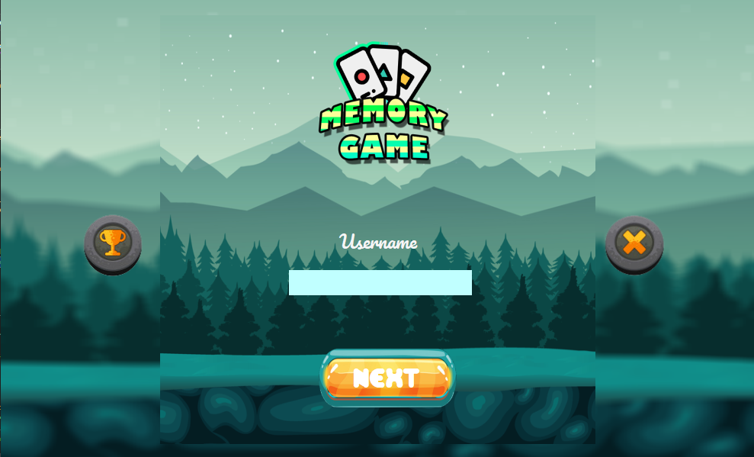

Login Button

Score board Button

Exit Button

|  |  |
| --- | --- |
| Login Button | Allow user to logged in and show the Menu Selection page |
| Score board button | The Score board button function to exit the application |
| Exit Button | The exit button function to exit the application |

* When username textbox empty will show error message and not proceed to next form

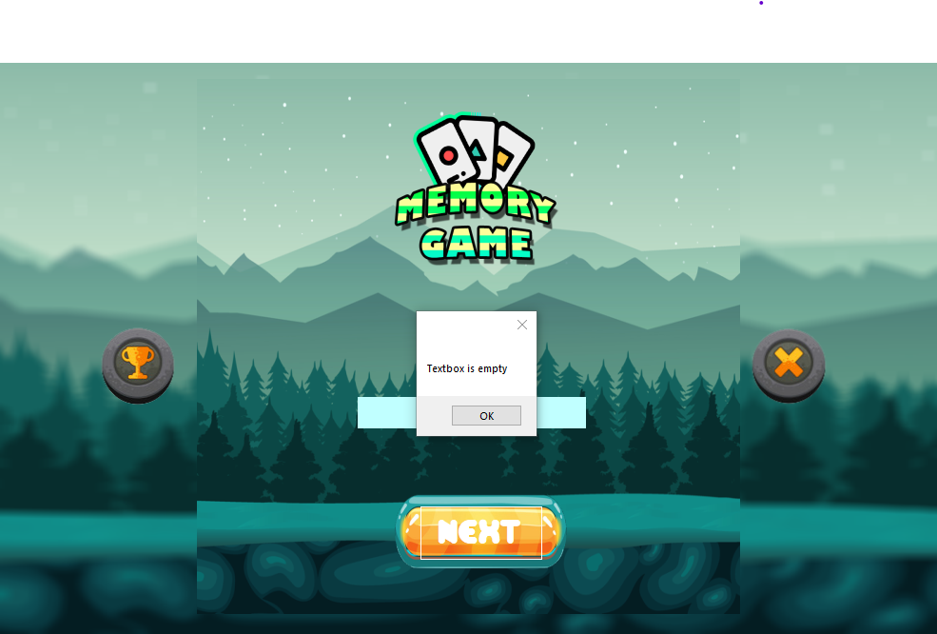

4.4.3 Menu Selection

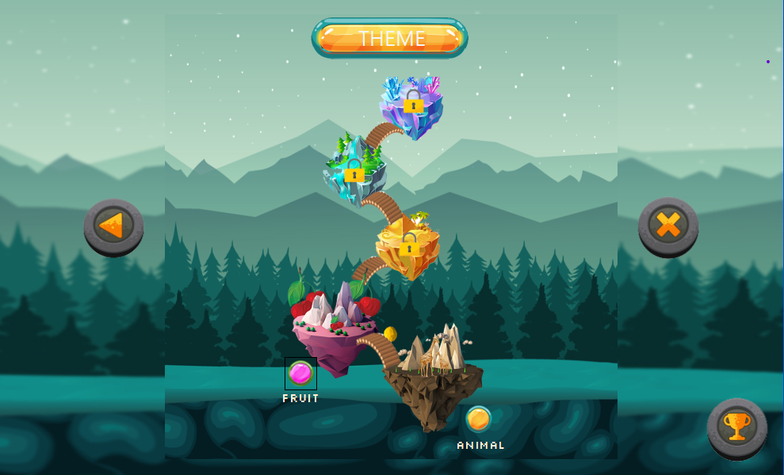

3

5

2

1

4

|  |  |  |
| --- | --- | --- |
| 1 | Back Button | The back button function to go to login page the application |
| 2 | Exit Button | The exit button function to exit the application |
| 3 | Fruit Button | The fruit button function to show Fruit Selection page |
| 4 | Animal Button | The animal button function to show Animal Selection page |
| 5 | Score Button | Allow user to view their past score |

4.4.4 Fruit

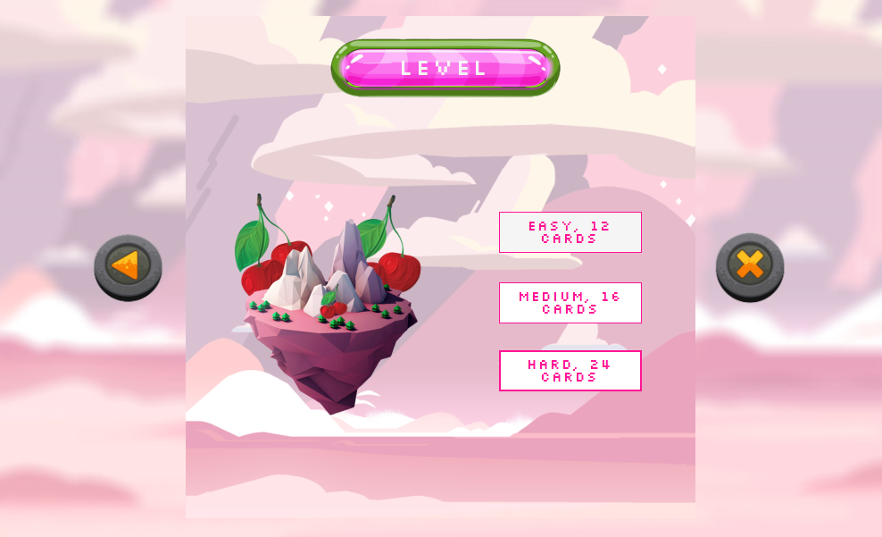

5

4

3

1

2

|  |  |  |
| --- | --- | --- |
| 1 | Back Button | The back button function to go to login page the application |
| 2 | Exit Button | The exit button function to exit the application |
| 3 | Easy Button | Allow user to play game that consists 12 Cards |
| 4 | Medium Button | Allow user to play game that consists 16 Cards |
| 5 | Hard Button | Allow user to play game that consists 24 Cards |

4.4.5 Animal

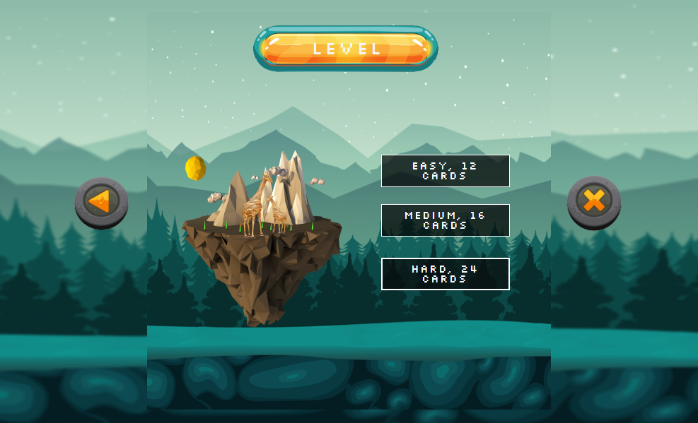

3

4

5

2

1

|  |  |  |
| --- | --- | --- |
| 1 | Back Button | The back button function to go to login page the application |
| 2 | Exit Button | The exit button function to exit the application |
| 3 | Easy Button | Allow user to play game that consists 12 Cards |
| 4 | Medium Button | Allow user to play game that consists 16 Cards |
| 5 | Hard Button | Allow user to play game that consists 24 Cards |

4.4.6 Fruit Easy Card Level

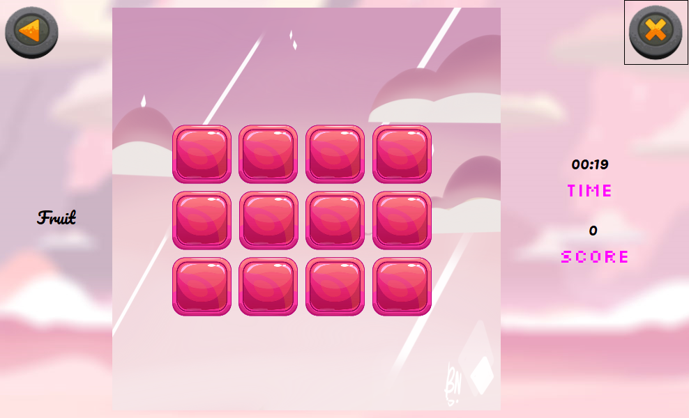

2

3

4

5

1

|  |  |  |
| --- | --- | --- |
| 1 | Back Button | The back button function to go back to menu page |
| 2 | Exit Button | The exit button function to exit the application |
| 3 | Timer | Allow user to keep track of time |
| 4 | Score | Allow user to view his or her score |
| 5 | Card Holder | Function to hold the cards |

* Before the game starts, All the cards are shown for 5 second to allow user to memorize the cards

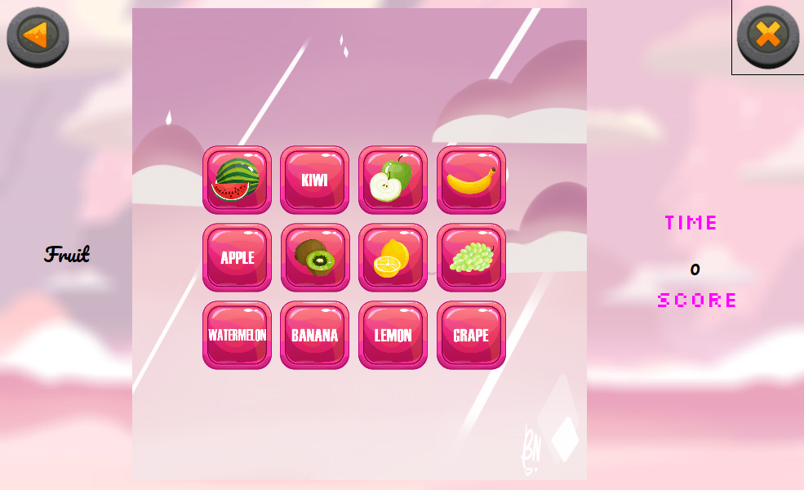

* When user unable to match all the cards within the time given, a Times Up message will pop up

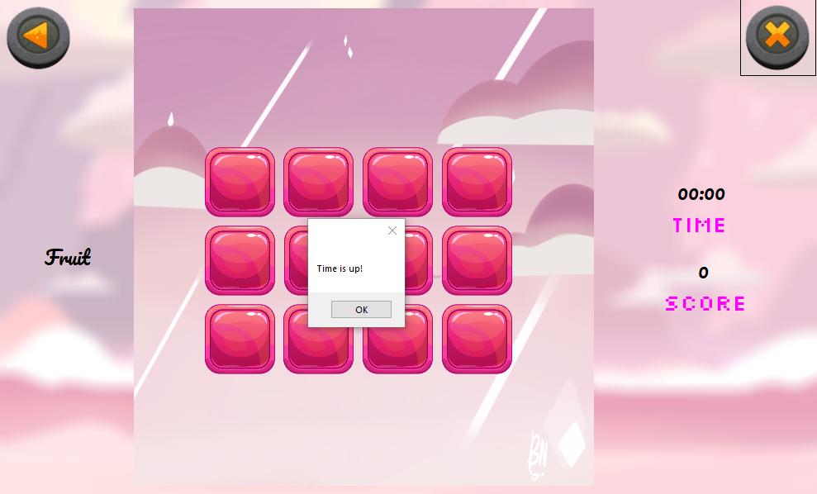

* When the user finish matching all the cards, an congratulation message will pop up

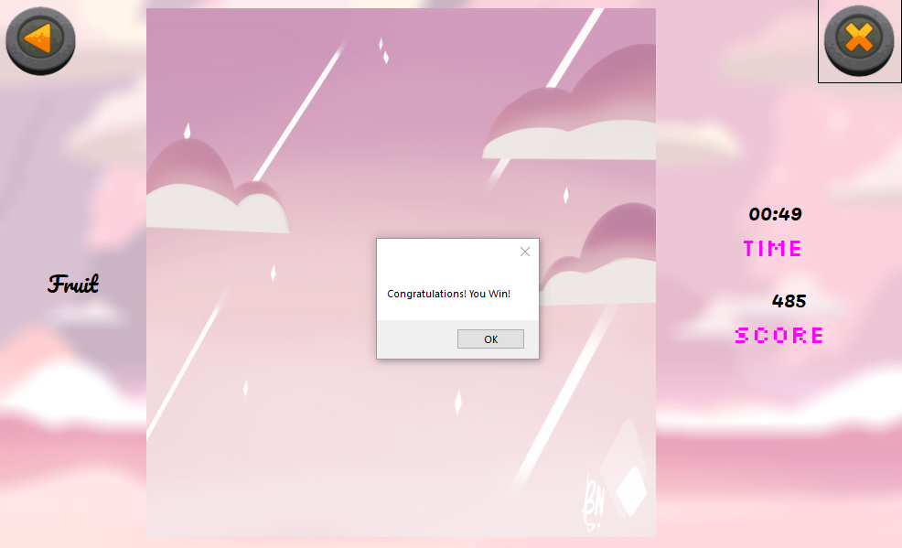

4.4.7 Fruit Medium Level

1

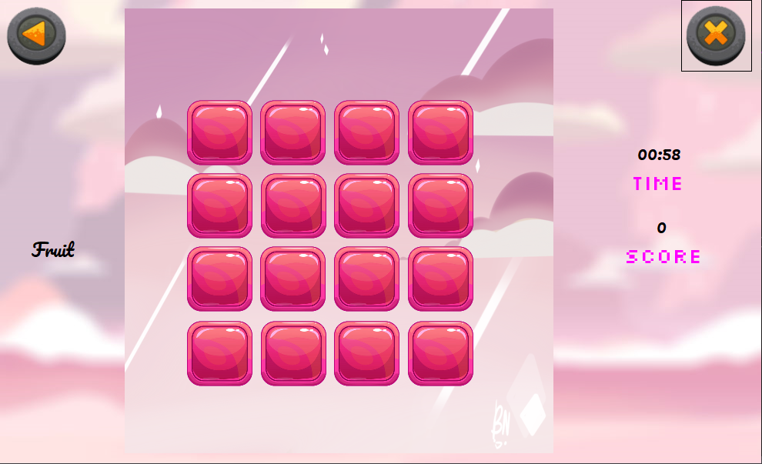

2

5

4

3

|  |  |  |
| --- | --- | --- |
| 1 | Back Button | The back button function to go back to menu page |
| 2 | Exit Button | The exit button function to exit the application |
| 3 | Timer | Allow user to keep track of time |
| 4 | Score | Allow user to view his or her score |
| 5 | Card Holder | Function to hold the cards |

* Before the game starts, All the cards are shown for 5 second to allow user to memorize the cards

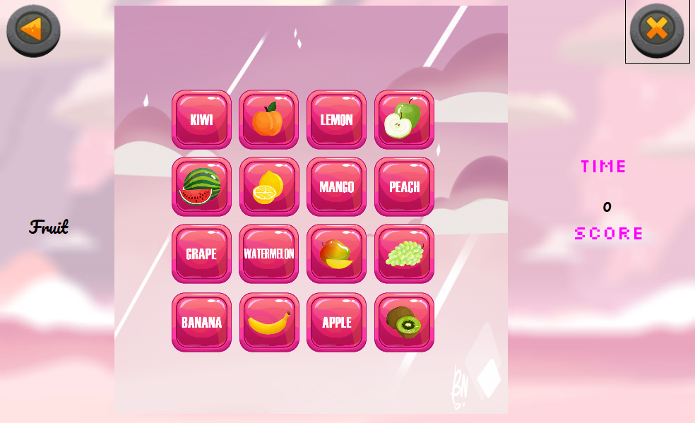

* When user unable to match all the cards within the time given, a Times Up message will pop up



* When the user finish matching all the cards, an congratulation message will pop up



4.4.8 Fruit Hard Level

5

1

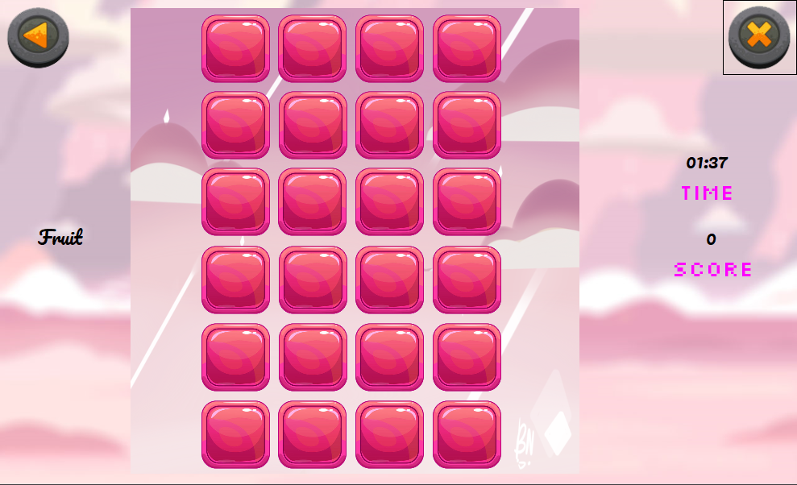

4

3

2

|  |  |  |
| --- | --- | --- |
| 1 | Back Button | The back button function to go back to menu page |
| 2 | Exit Button | The exit button function to exit the application |
| 3 | Timer | Allow user to keep track of time |
| 4 | Score | Allow user to view his or her score |
| 5 | Card Holder | Function to hold the cards |

* Before the game starts, All the cards are shown for 5 second to allow user to memorize the cards



* When user unable to match all the cards within the time given, a Times Up message will pop up



* When the user finish matching all the cards, an congratulation message will pop up



4.4.9 Animal Easy Level

1

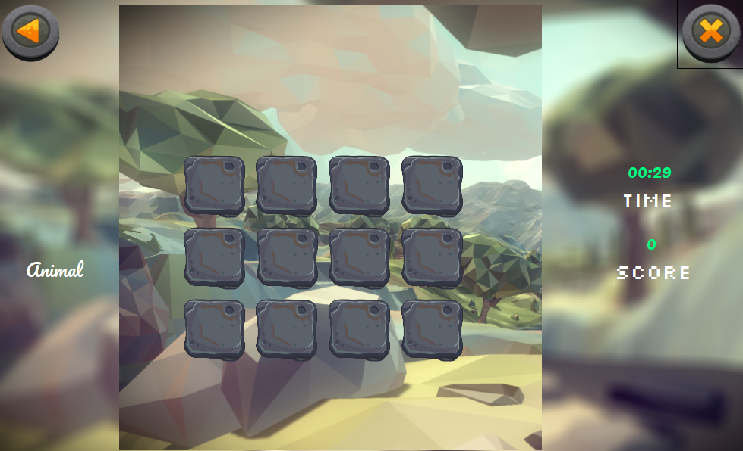

3

5

4

2

|  |  |  |
| --- | --- | --- |
| 1 | Back Button | The back button function to go back to menu page |
| 2 | Exit Button | The exit button function to exit the application |
| 3 | Timer | Allow user to keep track of time |
| 4 | Score | Allow user to view his or her score |
| 5 | Card Holder | Function to hold the cards |

* Before the game starts, All the cards are shown for 5 second to allow user to memorize the cards

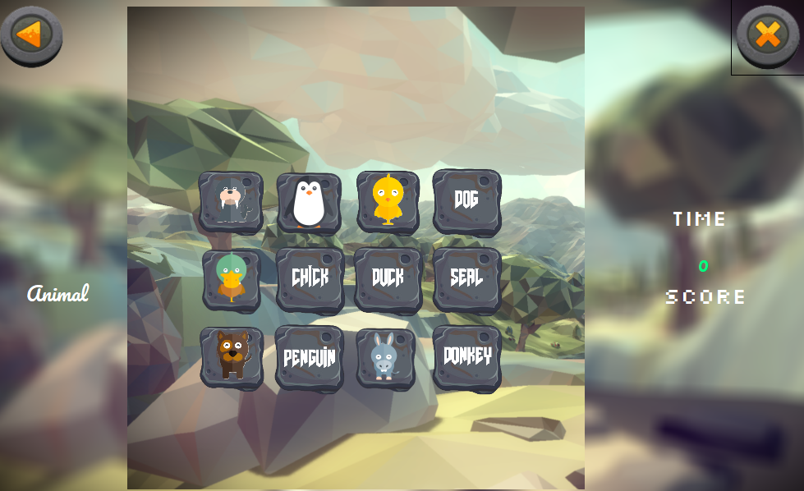

* When user unable to match all the cards within the time given, a Times Up message will pop up

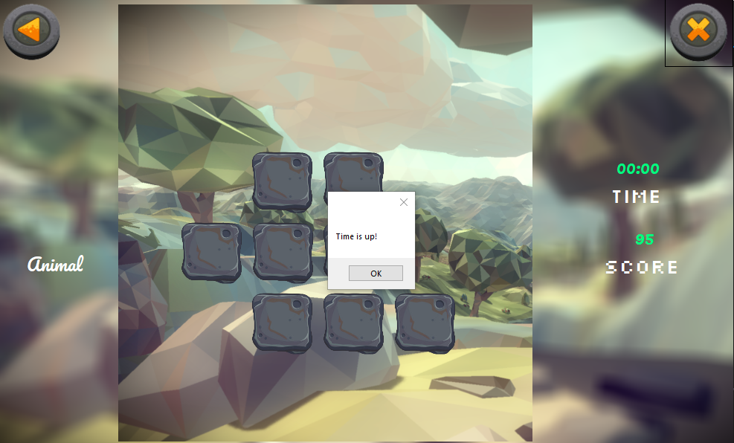

* When the user finish matching all the cards, an congratulation message will pop up

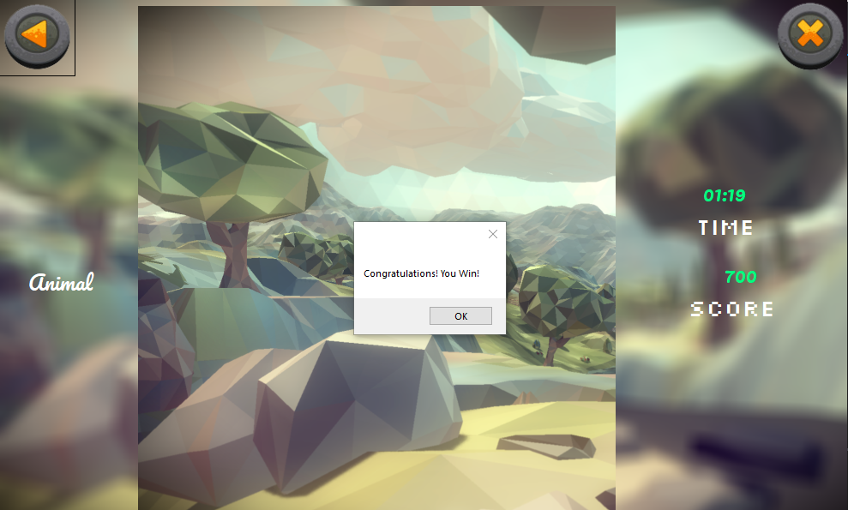

4.4.10 Animal Medium Level

1

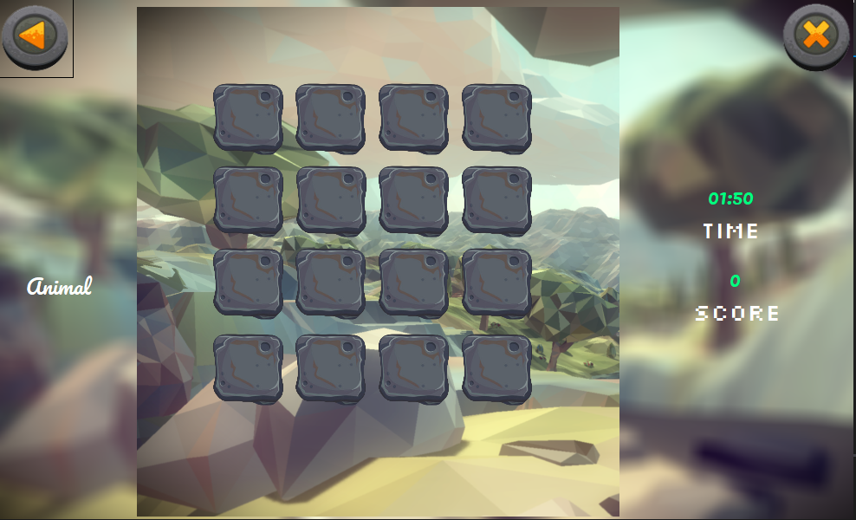

5

4

3

2

|  |  |  |
| --- | --- | --- |
| 1 | Back Button | The back button function to go back to menu page |
| 2 | Exit Button | The exit button function to exit the application |
| 3 | Timer | Allow user to keep track of time |
| 4 | Score | Allow user to view his or her score |
| 5 | Card Holder | Function to hold the cards |

* Before the game starts, All the cards are shown for 5 second to allow user to memorize the cards

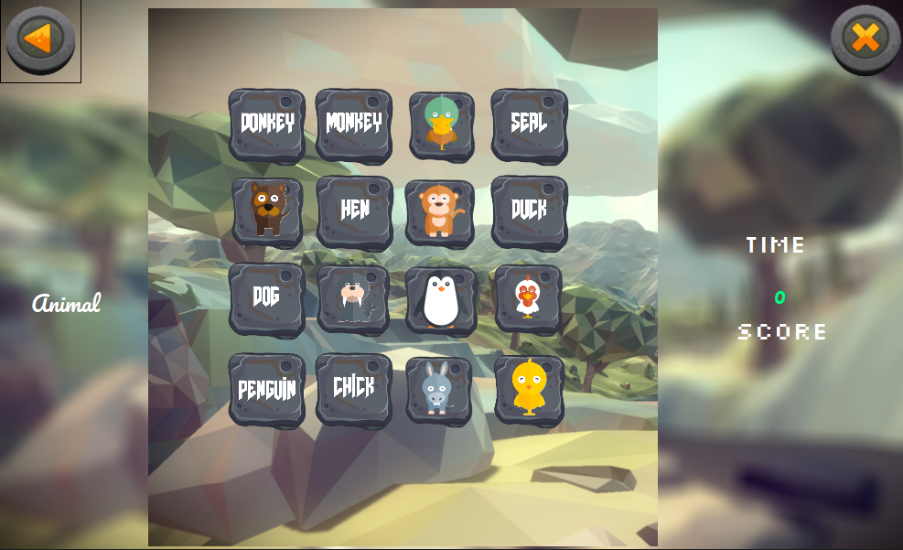

* When user unable to match all the cards within the time given, a Times Up message will pop up



* When the user finish matching all the cards, an congratulation message will pop up



4.4.11 Animal Hard Level

2

5

1

3

4

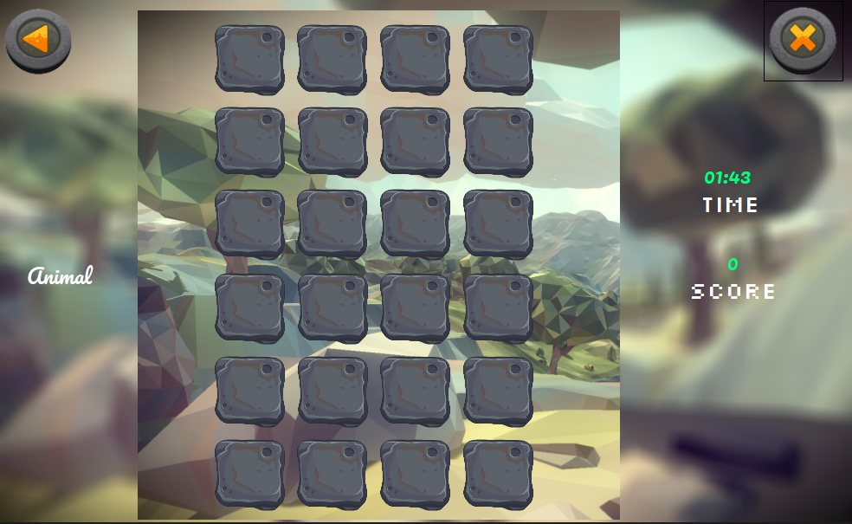

|  |  |  |
| --- | --- | --- |
| 1 | Back Button | The back button function to go back to menu page |
| 2 | Exit Button | The exit button function to exit the application |
| 3 | Timer | Allow user to keep track of time |
| 4 | Score | Allow user to view his or her score |
| 5 | Card Holder | Function to hold the cards |

* Before the game starts, All the cards are shown for 5 second to allow user to memorize the cards

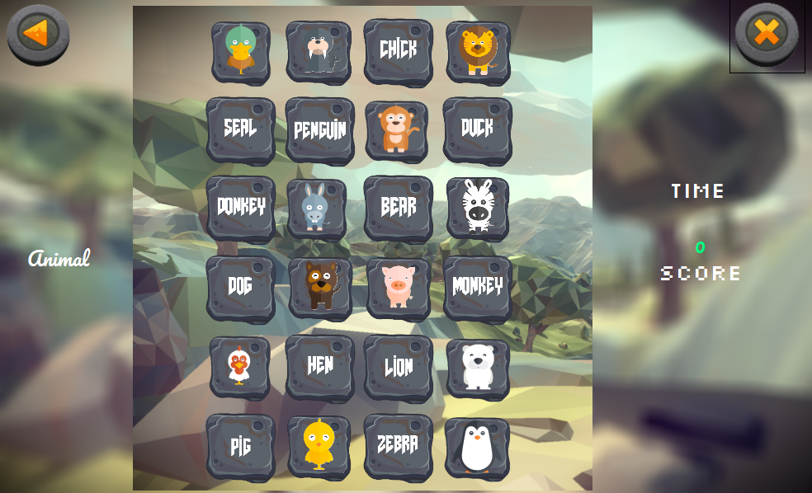

* When user unable to match all the cards within the time given, a Times Up message will pop up



* When the user finish matching all the cards, an congratulation message will pop up



4.4.12 Score board Menu

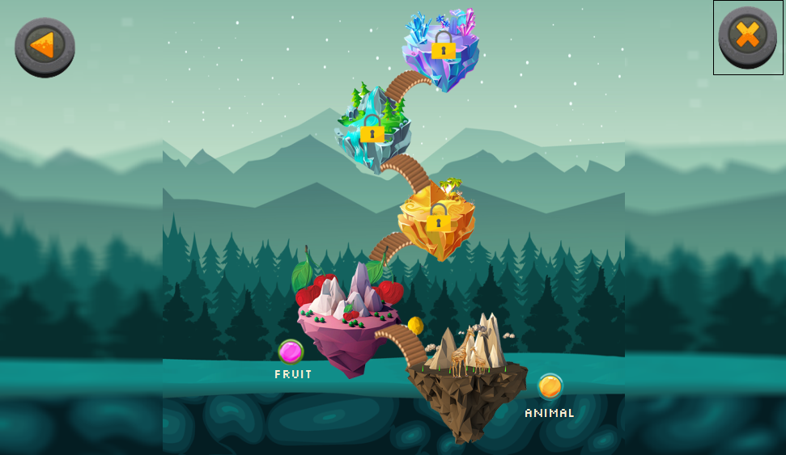

4

3

1

2

|  |  |  |
| --- | --- | --- |
| 1 | Back Button | The back button function to go back to menu page |
| 2 | Exit Button | The exit button function to exit the application |
| 3 | Fruit Button | Allow user to view fruit Score board menu |
| 4 | Animal button | Allow user to view animal Score board menu |

4.4.13 Fruit Score board

1

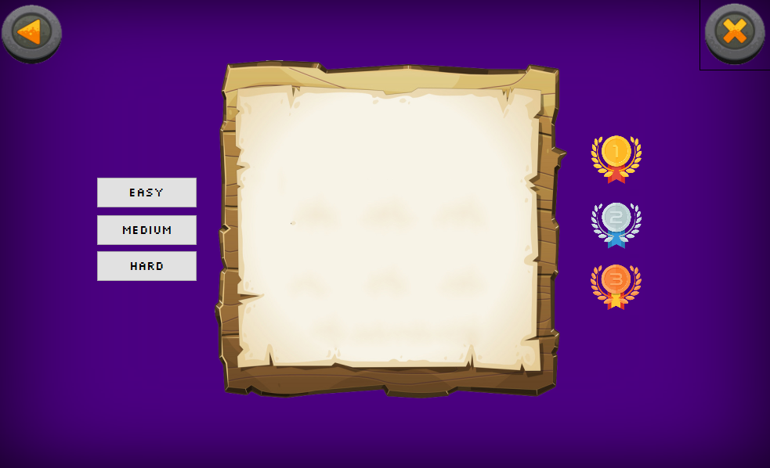

9

6

7

8

4

3

5

2

|  |  |  |
| --- | --- | --- |
| 1 | Back Button | The back button function to go back to menu page |
| 2 | Exit Button | The exit button function to exit the application |
| 3 | Easy Button | Allow user to view fruit Score board menu |
| 4 | Medium button | Allow user to view fruit Score board menu |
| 5 | Hard Button | Allow user to view fruit Score board menu |
| 6 | First Rank Label | Allow user to view top first name |
| 7 | Second Rank Label | Allow user to view top second name |
| 8 | Third Rank Label | Allow user to view top third name |
| 9 | Score table | Allow user to view all player’s score |

* When user click the Easy button, it will show all the player’s score and the ranking

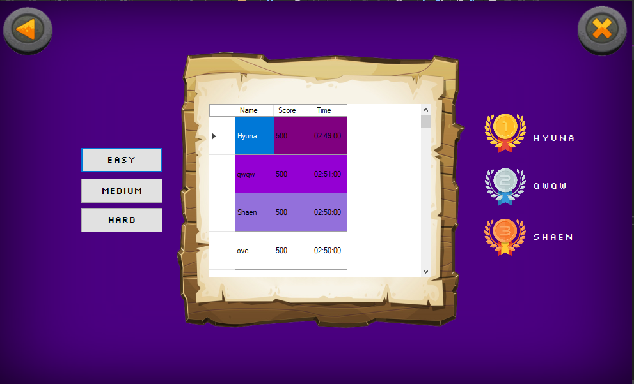

* When user click the Medium button, it will show all the player’s score and the ranking

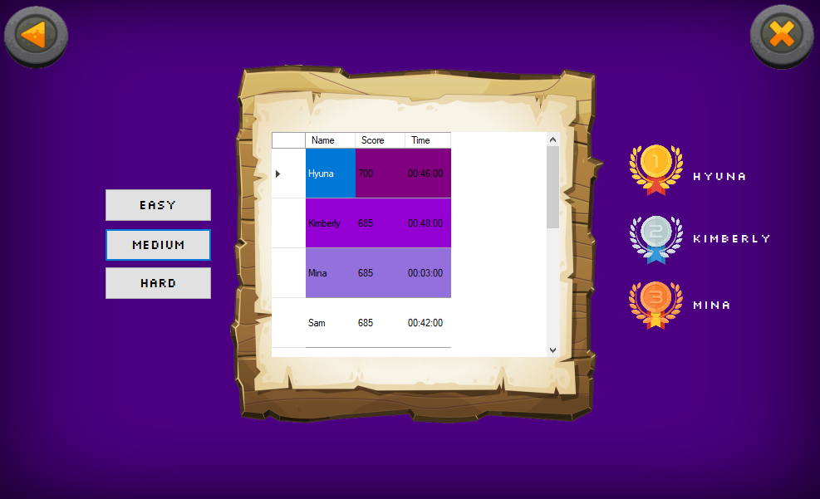

* When user click the Hard button, it will show all the player’s score and the ranking

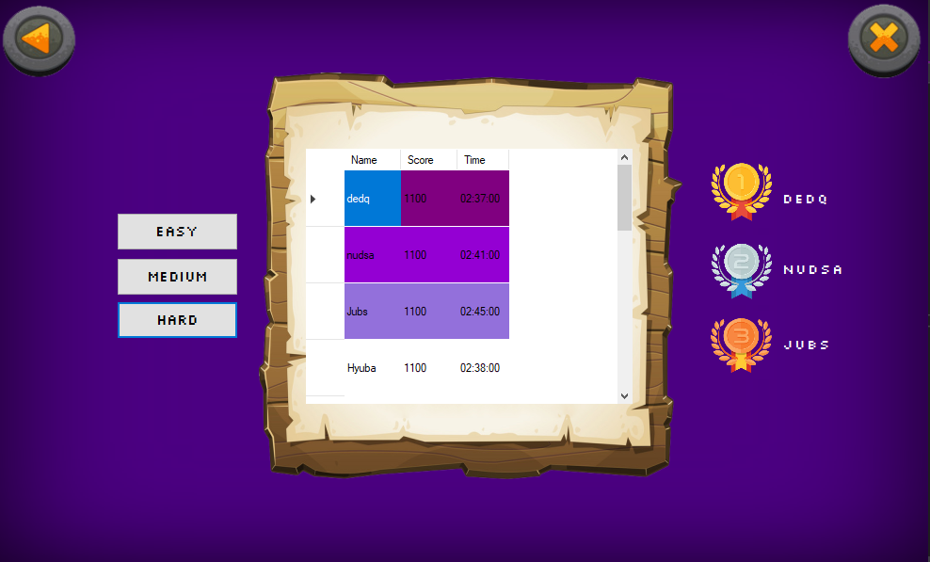

4.4.14 Animal Score board

1

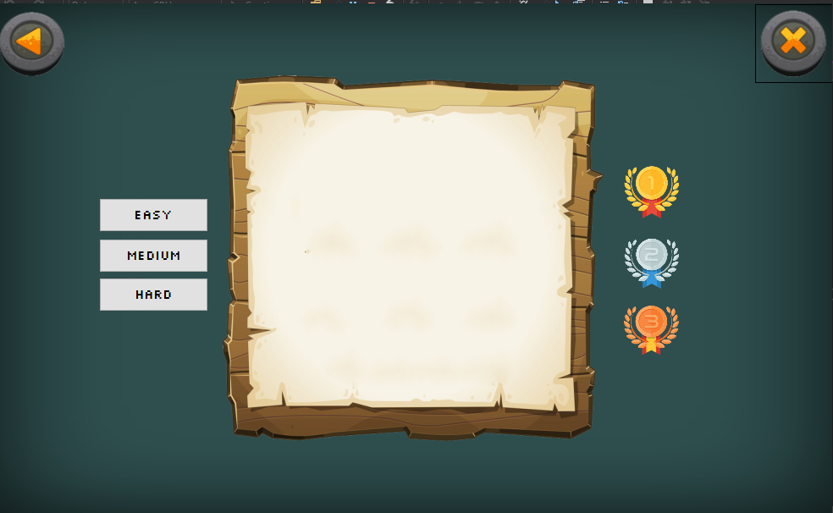

9

6

7

8

4

3

5

2

|  |  |  |
| --- | --- | --- |
| 1 | Back Button | The back button function to go back to menu page |
| 2 | Exit Button | The exit button function to exit the application |
| 3 | Easy Button | Allow user to view animal Score board menu |
| 4 | Medium button | Allow user to view animal Score board menu |
| 5 | Hard Button | Allow user to view animal Score board menu |
| 6 | First Rank Label | Allow user to view top first name |
| 7 | Second Rank Label | Allow user to view top second name |
| 8 | Third Rank Label | Allow user to view top third name |
| 9 | Score table | Allow user to view all player’s score |

* When user click the Easy button, it will show all the player’s score and the ranking

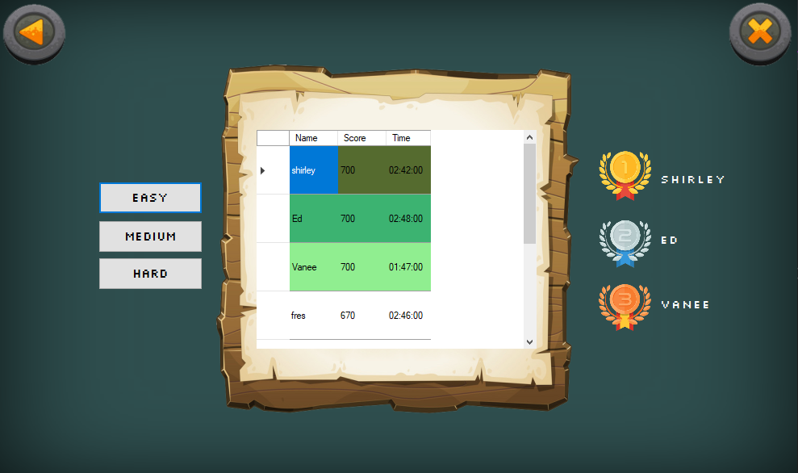

* When user click the Medium button, it will show all the player’s score and the ranking

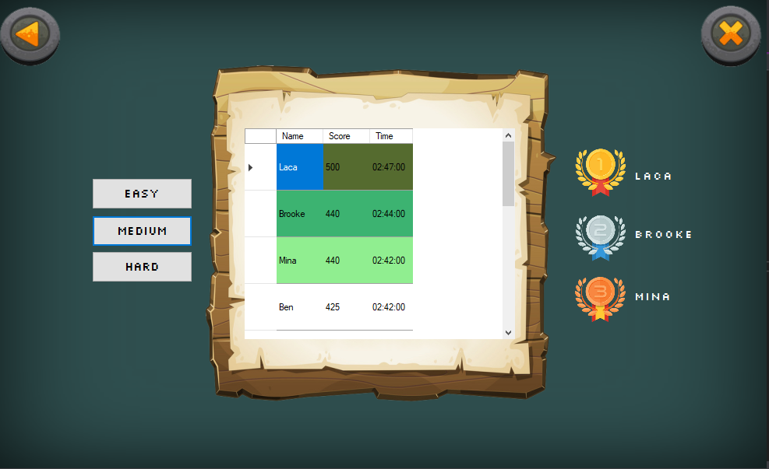

* When user click the Hard button, it will show all the player’s score and the ranking

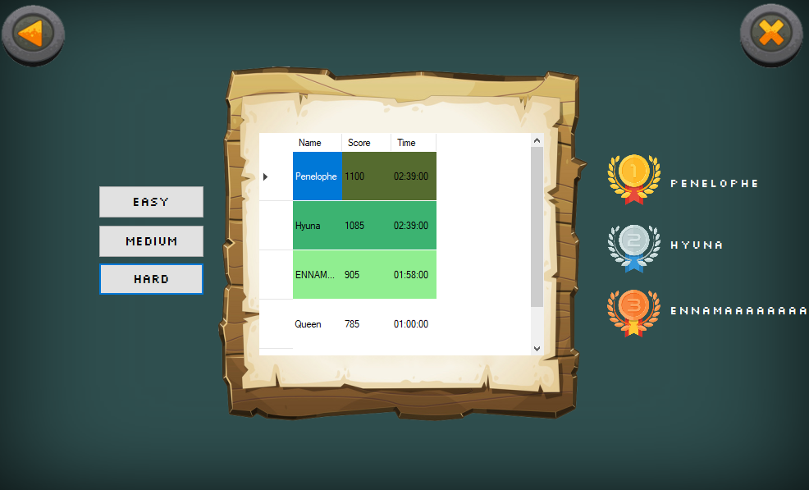

4.4.15 Score

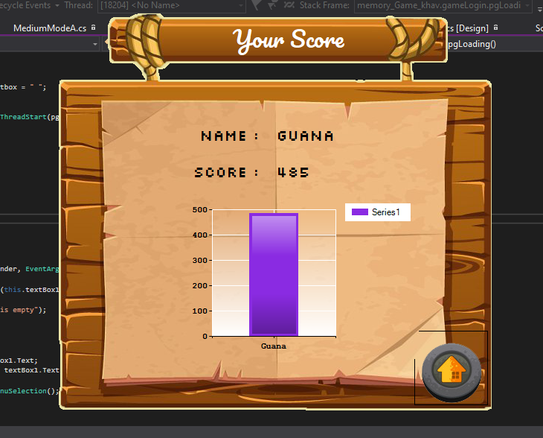

3

2

4

1

|  |  |  |
| --- | --- | --- |
| 1 | Home Button | The home button function to go back to login page |
| 2 | Name Label | Allow user to view his/hers name |
| 3 | Score Label | Allow user to view his/hers score |
| 4 | Chart | Allow user to see their past and current score at a bar chart |

**Self-assesment**

|  |  |  |  |  |  |  |  |  |
| --- | --- | --- | --- | --- | --- | --- | --- | --- |
|  | % | P | A | S | G | E | O | Comments |
| Object Oriented Design  (including UML diagrams and how the design is reflected into code and any other technical documentation included in the report) | 15 |  | / |  |  |  |  | -technical documentation included |
| Well named variables and, methods. Decisions, Iteration. Overloading | 10 |  |  |  | / |  |  | Well named variable and methods used almost in all form  Overloading is not used in any form |
| Objects and Classes. Collections | 10 |  |  |  |  | / |  | Objects and classes was used and Collection is used in EasyModeA, MediumModeA, HardMode, EasyModeF, MediumModeF and HardModeF Form. |
| Eventscontrols. Validation | 10 |  |  |  |  | / |  |  |
| Threads. Animations | 10 |  |  |  |  | / |  | Animation and threads was used in Main page for ProgressBar |
| Inheritance Interfaces | 10 | / |  |  |  |  |  | Inheritance and interfaces was not used at all in any form |
| Persistence – storing and reading data from a db | 10 |  |  |  |  |  | / | -All data is stored in sql server and it was used in score, scoreboard and scoreboar1 forms. |
| Patterns | 5 |  |  |  |  |  |  |  |
| Extra features ( such using web services) | 5 |  | / |  |  |  |  | - Extra feature: Music is added in EasyModeA, MediumModeA,HardMode,EasyModeF,MediumModeF,HardModeF forms. |
| Acceptance Testing  (includes how well the app is presented and the ability to answer technical questions) | 10 |  |  |  |  |  |  |  |
| Accurate Self- Assessment | 5 |  |  |  |  |  |  |  |
| Possible AO? |  |  |  |  |  |  |  |  |